smMIP Assay Submission Guidelines
The OICR Genomics program offers a smMIP (small Molecular Inversion Probe) service with pre-defined panels. smMIP assays are being used for cost-effective targeted sequencing for high sample volume studies where high detection of accuracy, even of low variant allele frequencies, is desired. Please review the following guidelines carefully and then contact OICR Genomics staff at genomics.inquires@oicr.on.ca to initiate the project opening process.
Sample submission format
Each batch of samples to be processed simultaneously must have a minimum of 24 and maximum of 46 samples. The minimum sample count is determined by the total NGS library yield required for a size selection step in the protocol. Due to the nature of the assay and consumption of consumables on a per plate basis, a minimum plate charge will apply for batches of less than 32 samples.
Submission of samples in plate format is required. Up to 46 samples must be arrayed in the left half of a 96 well plate using columns 1 to 6 and leaving well G6 and H6 empty for addition of control set as shown in the figure below. Wells must be filled by column (e.g. A1→H1, A2→H2, etc.). Shaded wells must be left empty. When submitting fewer than 46 samples at a time, columns should be filled from left to right leaving only one column partially filled upon submission.
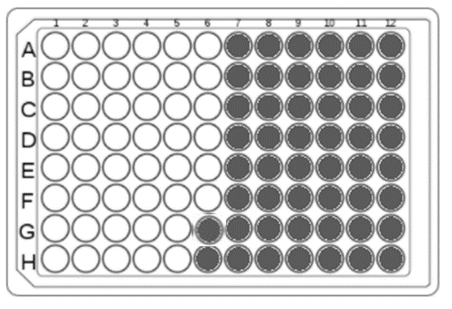
If samples from multiple projects are being submitted as whole plates, please label samples with their corresponding project name in your submission forms.
Samples must be submitted to staff at OICR’s Tissue Portal (tissue.portal@oicr.on.ca) with the appropriate submission sheets completed. 300ng of DNA for each sample must be submitted in 12uL of nuclease free water for a normalized concentration of 25ng/uL. Quantifications determined with a fluorescence based method (Qubit, Quant-IT) need to be provided at the time of submission. OICR staff will take user supplied concentrations as correct and will not re-quantify samples to verify accuracy. Failure to provide accurately quantified sample(s) may lead to poor library quality or sample failures which will be billable.
Panels and Sequencing Options
Current panels available through the Genome Research Platform are:
- Myeloid_smMIPS_panel (286 smMIPs)
- CB_Paired_B_ALL_smMIPS_panel (120 smMIPs)
- Myeloid_CML_smMIPS_panel (333 smMIPs)

